SEOInforce problems given:
Description: An SEO tool for domain audits, competitor comparisons, and white-label dashboards.
Current Development Issues:
• Audit tools display no output or real results.
• No ability to add client projects or compare competitors.
• Admin UI is incomplete.
Missing or Incomplete Features:
• Launch audit logic to analyze domains + keywords.
• Build client-facing SEO dashboard with branding.
• Enable monthly billing + upgrade path for agencies.

PROBLEMS SOLVED:s
1)please go to dashboard give link & wait for 60 secs it will display real outputs , I used multiples real APIS to do it
2)now you can add competitors and keywords
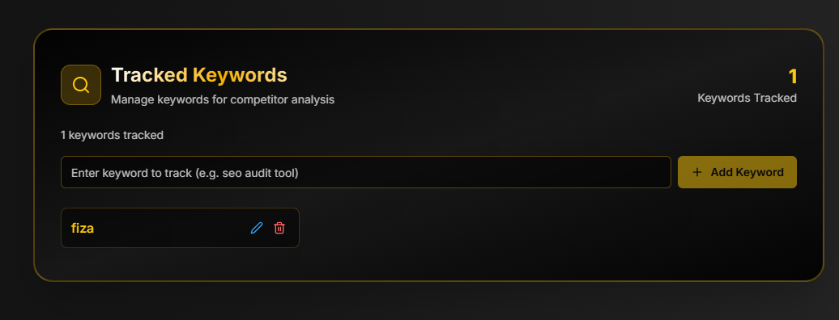
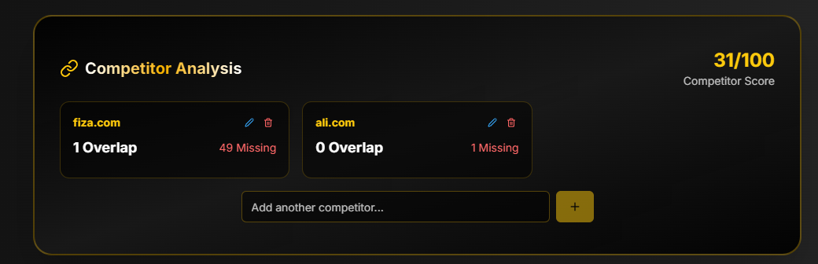
3)now complete admin panel with all features

Thanks

